Problem-1: Inheritance and Object Reference Manipulation in Java.
Code:
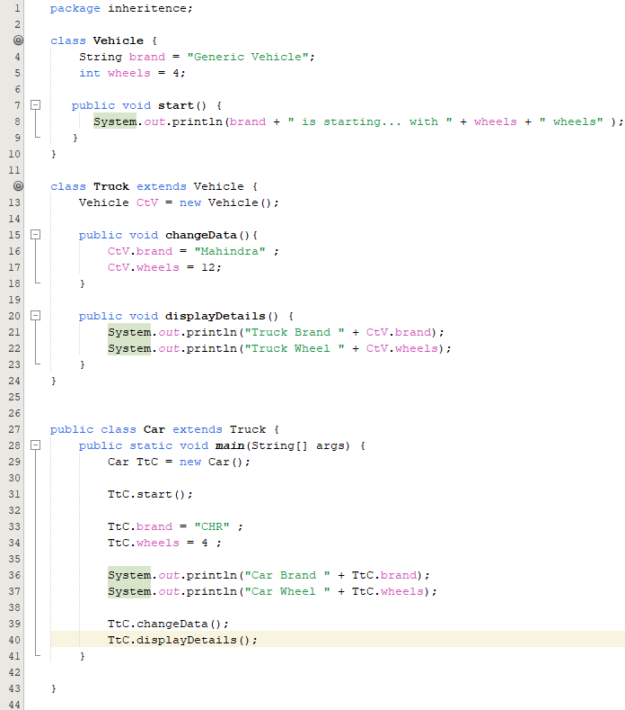
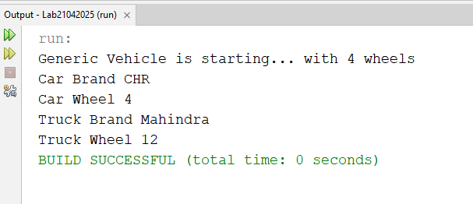

Problem-2: Accessing Members of Inner Classes in Java
Code:
